So now as we have seen that Platt’s Curve does not meet the expected outcome when the Calib. Does not look like Sigmoidal Curve.

So lets take an example of curve which does not look like sigmoidal curve.

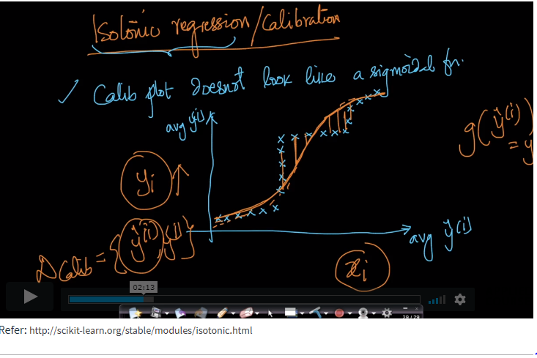

So what isotonic regression means is when we have plots like above shown which are generally called as step plots which means they tends to behave in steps.

So we will break them in steps or say multiple portion of lines and set some thresholds with the start and end of lines.

And we want to predict probability of Yi we will first determine between which threshold its corresponding value lies.

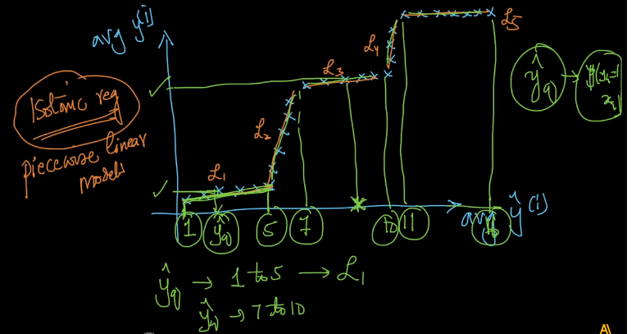

That means as per above image if we want to predict probability of Yi(hat) = 7 so we know it lies in second line and we will than use eq. of second line to predict its corresponding

Probability of Yi.

But how we set this threshold is still the question?

The whole concept is determining the values of a1,a2,a3,…,an i.e. threshold values and we don’t want too many lines say 1million and it is not worthy.

We just want enough lines.

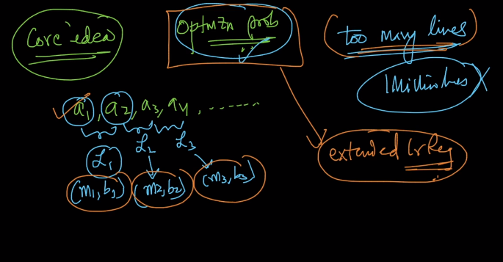

And between each threshold there is line and so for that line we need to find slope and intercept.

So this whole problem looks like extended LR.

But there is one catch with isotonic Regression.

In isotonic Regression we need large data as compared to Platt’s scaling because in Platt’s scaling we just needed to predict A and B but here we need to predict a1,a2,a3..,an and their corresponding Lines.

SO for predicting more parameters we need more data.

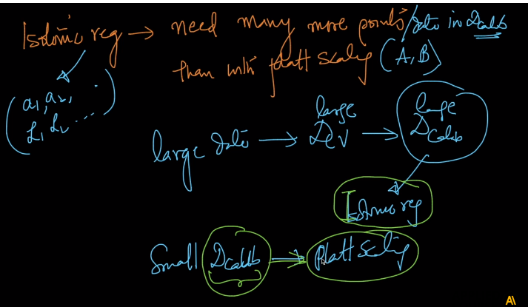

That’s the key difference about when to choose Platt’s Scaling and when to choose Isotonic regression.

**Comments:**

